**Python Module End Assignment (Comprehensive Assessment)**

**Due on 5th June 24**

**Submitted by Aiswarya Jayaprakash**

Congratulations on completing the Python module!   
  
As a culminating project, you'll be working with a dataset from ABC company, consisting of 458 rows and 9 columns. The company requires a comprehensive report detailing information about their employees across various teams. Your tasks include preprocessing the dataset, analyzing the data, and presenting your findings graphically. Here's a breakdown of what you need to do:  
  
Preprocessing:  
Correct the data in the "height" column by replacing it with random numbers between 150 and 180. Ensure data consistency and integrity before proceeding with analysis. (1 mark)

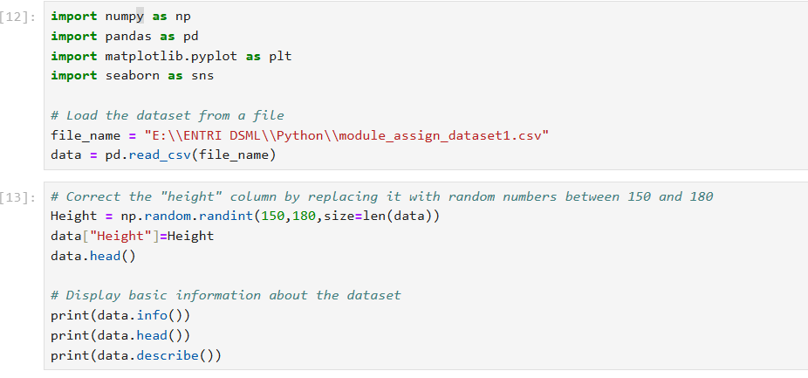  
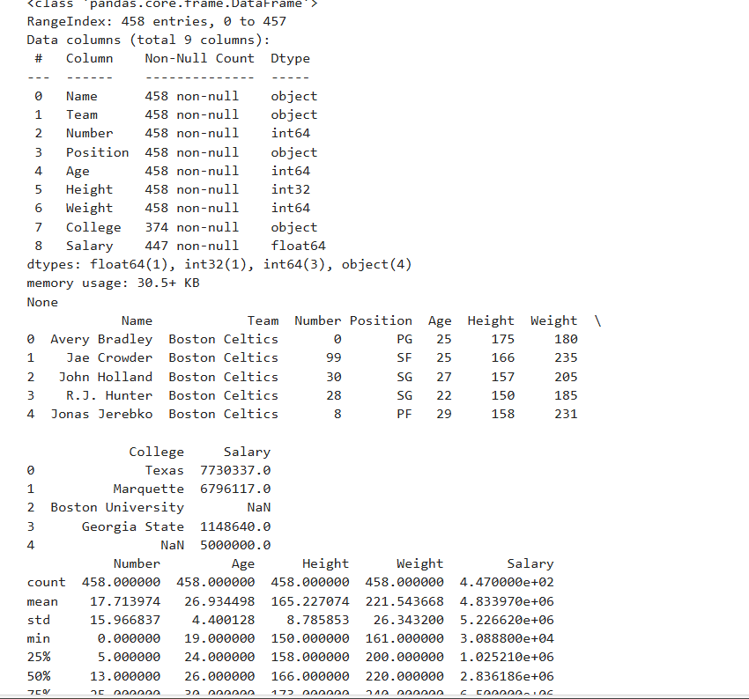

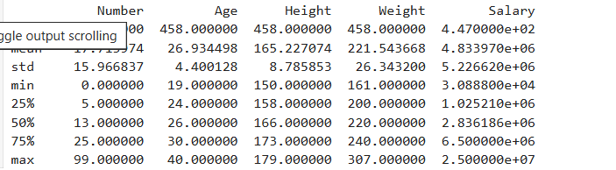

Analysis Tasks:  
**1.**Determine the distribution of employees across each team and calculate the percentage split relative to the total number of employees. (2 marks)

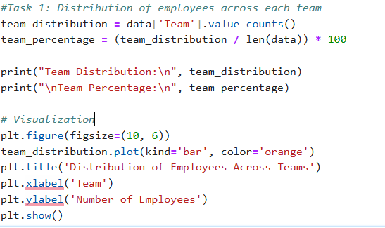

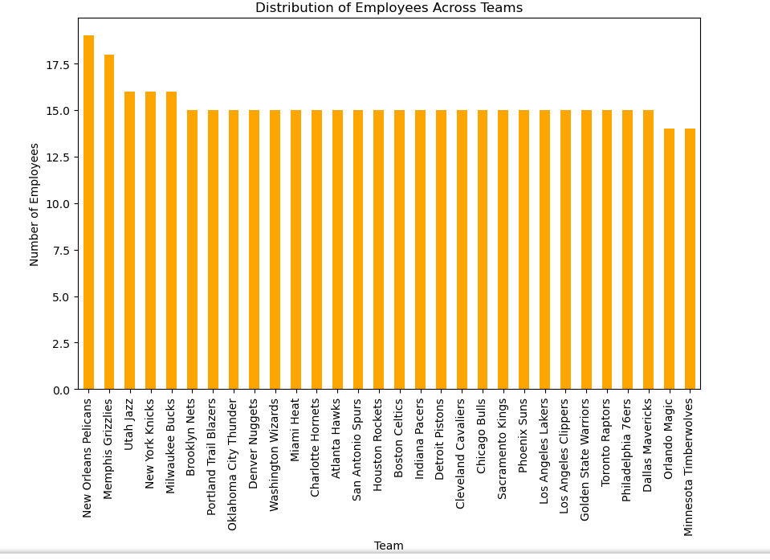

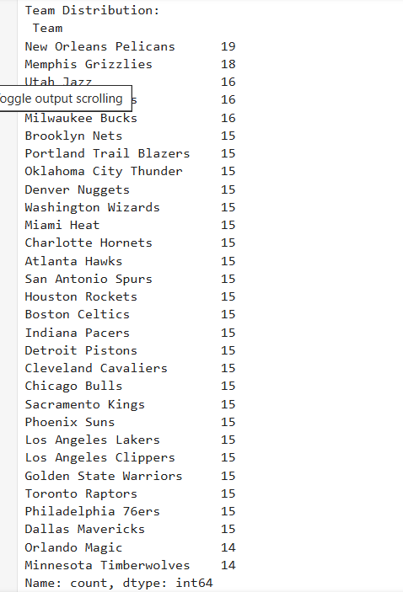

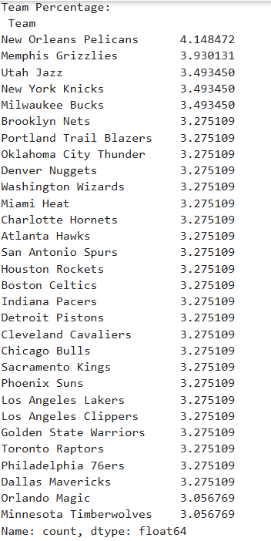

Data story: Plot analysis revealed that"new orlean pelican" team has the highest number of employees which is 19 followed by "Memphis Grizzilies" at 18. Further majority team has 15 employees.

**2.**Segregate employees based on their positions within the company. (2 marks)

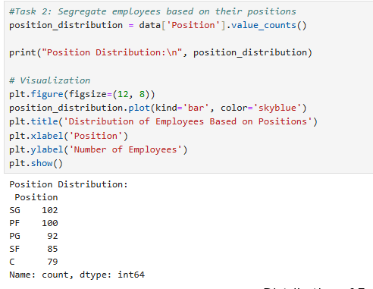

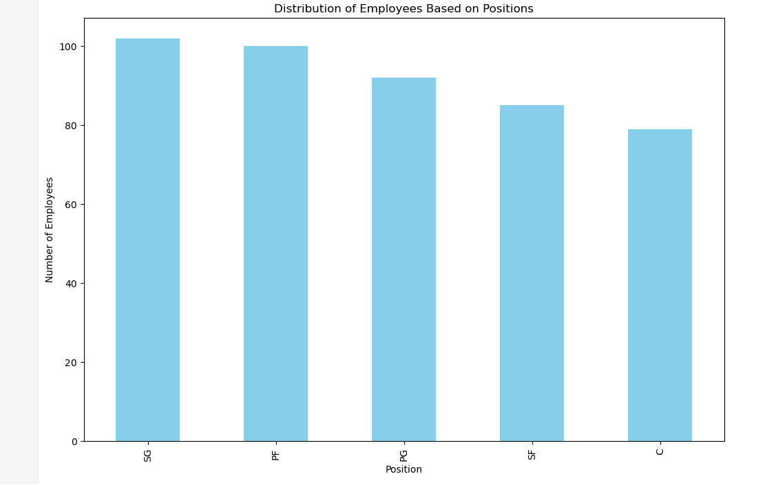

Data story: The bar plot showed that more than 100 employees belonged to SG position followed by PF position.

**3.**Identify the predominant age group among employees. (2 marks)

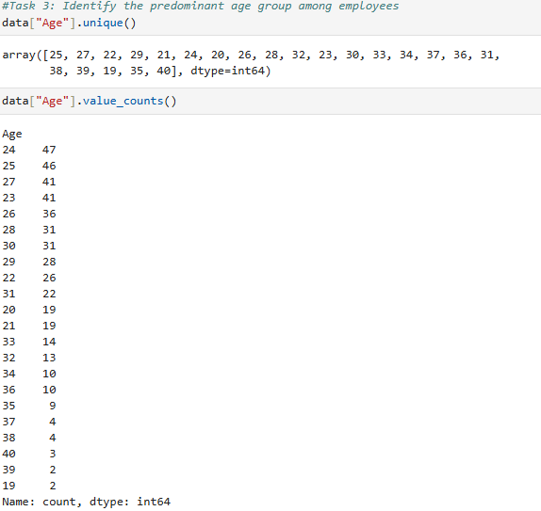

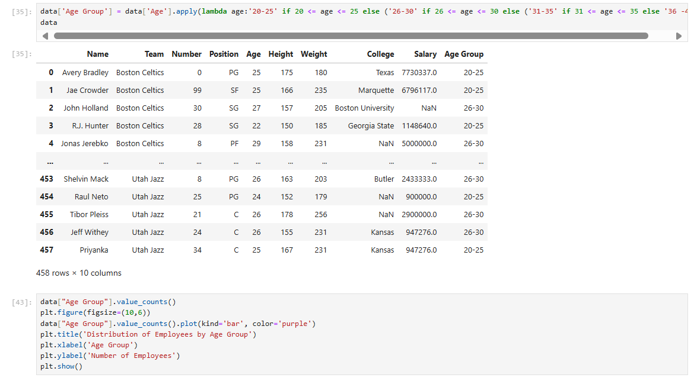

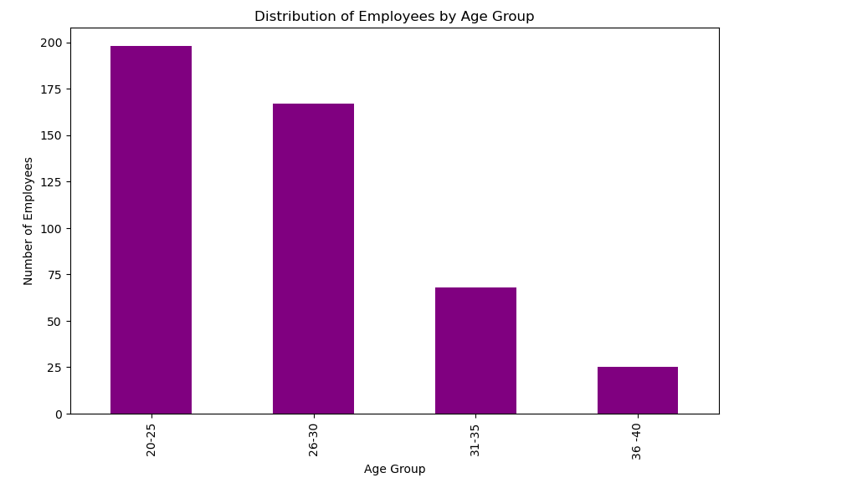

Data story: It is identified that most of the employees age falls within the age of 25, with 42 individuals in this group followed by 41 individuals with the age of 24. The bar plot analysis showed majority of employees about 198 individuals are under the age of 20-25. Apart from this, there are fewer individuals between the age range of 36-40

**4.**Discover which team and position have the highest salary expenditure. (2 marks)

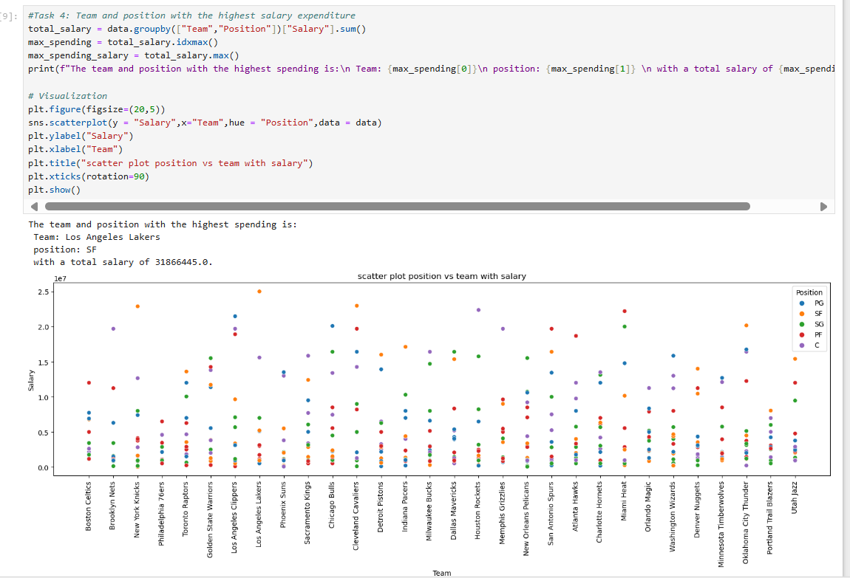

Data story: scatter plot analysis revealed that that Los angeles lakers standout as highest spending team when salary distribution was plotted across different positions within each team.

**5.**Investigate if there's any correlation between age and salary, and represent it visually. (2 marks)

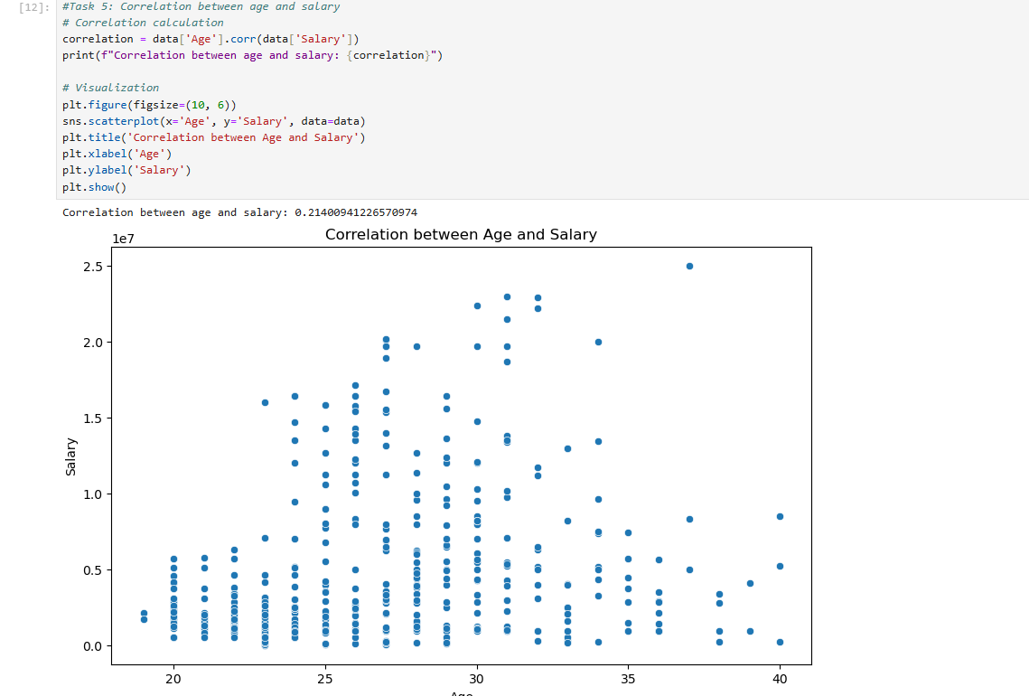

Data story: The correlation between age and salary: 0.21400941226570974 which is a positive correlation but the correlation values shows a weak relationship between age and salary. This means that as age increases, there's a tendency for salaries to increase slightly.

Graphical Representation:  
For each of the five analysis tasks, create appropriate visualizations to present your findings effectively. (5x2 = 10 marks)  
  
Data Story:  
Provide insights gained from the analysis, highlighting key trends, patterns, and correlations within the dataset. (3 marks)  
  
Timely Submission:  
Ensure timely submission of your project to earn an additional mark. (1 mark)  
  
Total Marks : 25  
  
By completing these tasks, you'll not only demonstrate your proficiency in Python programming but also your ability to analyze and communicate insights from real-world data.  
  
Download the dataset from this link.  
 <https://docs.google.com/spreadsheets/d/1VP9BE_eI2yl6uUHSm4mGiiwjRdoqCqnkcIjsv5Q2ex4/edit?usp=share_link>  
  
To submit the project:  
**1.**Create a repository on your GitHub account.  
2. Write a comprehensive overview of the project in the README file, summarizing the preprocessing steps, analysis tasks, graphical representations, insights gained, and any additional information.  
3. Upload a well-organized Jupyter Notebook file containing the code for the project, ensuring proper formatting and documentation.  
4. Include the dataset in the repository.  
5. Submit the link to your repository in the designated section on Google Classroom.  
  
Best of luck, and feel free to reach out if you have any questions or need assistance along the way!